# 浏览式阅读

## 1 自己的总结、评价以及应用

本文就介绍了这样一个东西：a context learning framework with graph model.

In this work, we design a target-context graph and employ a pairwise GCN to learn visual relations in the scene.

## 2 文章的主要问题（abstract、疑问句中）

## 3 结论（abstract以及conclusion中）

hand-crafted histogram features

文章提出了一种特征表示/提取的方法：

特征提取feature extraction model： Feature Fusion Net (FFN)

We propose a novel feature extraction model called Feature Fusion Net (FFN) for pedestrian image representation.

特征表示：deep feature representation

Utilizing color histogram features (RGB, HSV, YCbCr, Lab and YIQ) and texture features (multi-scale and multi-orientation Gabor features)

## 4 思路脉络（小标题中的关键句）

1. **Introduction**

为了解决supervised learning的calability problem，引入unsupervised re-id by clustering on the target unlabelled data [52, 53, 8] or transfering the knowledge from other labeled source dataset（reference dataset），但是仍然存在很大的问题：

难以识别the identity discriminative information（存在较大的类内差异和较小的类间差异，也就是说，同一目标之间的差异过大，而不同目标之间的差异又很小，这就形成了一种矛盾）

解决方法：we propose a novel soft multilabel learning to mine the potential label information in the unlabeled RE-ID data

如何表示unlabled person的特征？答：借用reference person

要求：Intuitively, a pair of images of the same person should be not only visually similar to each other (i.e. they should have similar absolute visual features), but also equally similar to any other reference person (i.e. they should also have similar relative comparative characteristics with respect to the reference persons).

有一个词： relative soft multilabel representation

hard negative pair

主要贡献 our contributions：

1. a novel soft multilabel reference learning method以mine the potential label information latent in the unlabeled RE-ID data
2. a novel deep model named deep soft multilabel reference learning (MAR)
3. Related Work

Unsupervised re-id的定义：Unsupervised RE-ID refers to that the target dataset is unlabelled but the auxiliary source dataset is not necessarily unlabelled.

先前的工作：

①transfer source label knowledge

②assuming strong prior knowledge

最近的工作：

1. exploiting video tracklet associations for unsupervised RE-ID
2. reducing the labelling effort is to minimize the labelling budget on the target（complementary to the unsupervised RE-ID）
3. 其他方法：use the labeled source dataset by the unsupervised domain adaptation [50, 7, 62, 48] to transfer the discriminative knowledge from the auxiliary source domain

（缺点：do not mine the discriminative information in the unlabeled target domain）

而我们的方法与上述不同：

because the transferred discriminative knowledge might be less effective in the target domain due to the domain shift [28] in discriminative visual clues

1. Approach

The feature representation of a person video in our model has two main components: space-time features and appearance features.

extracting the space-time features：HOG3D descriptor

extracting the appearance features：color histograms and LBP features

目标函数：

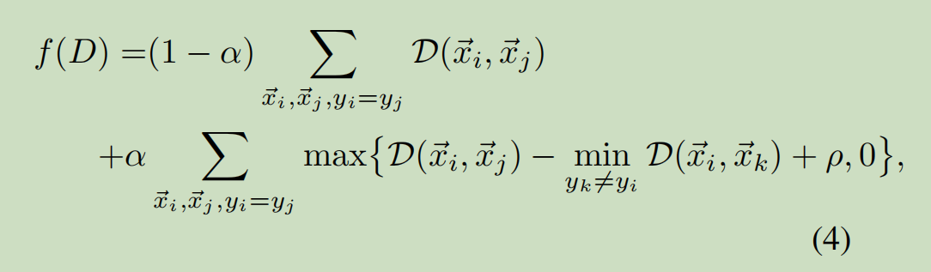

We call the second term the top-push constraint.

**4. Experiment**

1. **Conclusion**

there are more ambiguities in video-based features than still-image-based features.so we introduce a top-push constraint to quantify ambiguous video representation.

下图就是op-push constraint

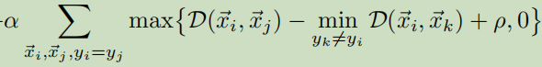

## 5 难理解点

专业术语：

different illumination：照明

Occlusion：遮挡

context information：上下文信息

probe-gallery pair：探测库对

contextual instance expansion module：上下文实例拓展模块

multi-camera surveillance systems：多摄像机监控系统 surveillance：监视

intra-class variations：组内变异 background clutter：背景混乱

manually cropped image snapshots or video clips：手动裁剪的图像快照或视频剪辑

appearance cue：外观提示 manual annotations：手动注释 semantic group：语义群

spatial and temporal cue：空间和时间线索 texture：纹理

latent subspace：潜在子空间